EXPERIMENT-6
6. A delivery robot must reach its destination using both actual travel cost and estimated remaining distance. Implement A* Search Algorithm. Obtain the optimal path using heuristic and path cost.
PROGRAM:

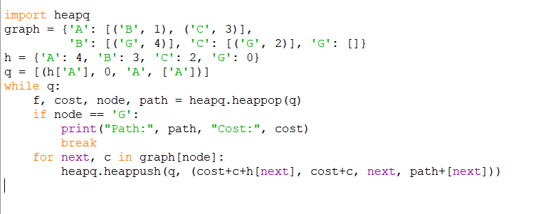

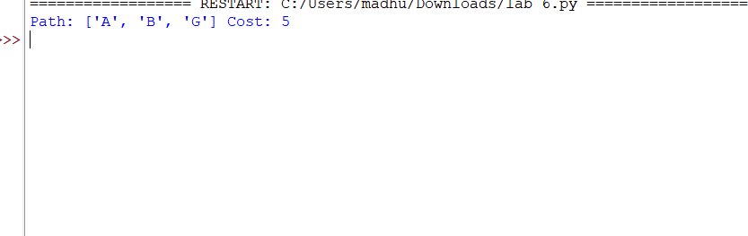
OUTPUT:

